**2.3 List of Use Case**

**2.3.1 <Borrower>Overview Use Case**

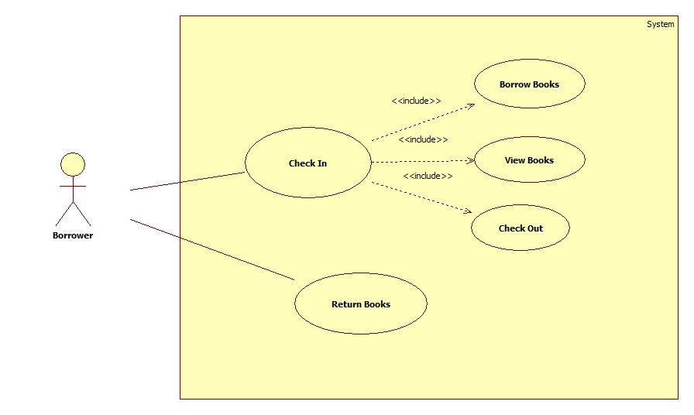

**Figure 1: < Borrower > Overview Use Case**

**2.3.1.1 < Borrower > Borrower Return Books**

**Use Case Diagram**

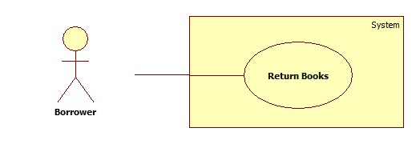

**Figure 2: < Borrower > Borrower Return Books**

**Use Case Specification**

|  |  |  |  |
| --- | --- | --- | --- |
| **USE CASE – LAR01** | | | |
| **Use Case No.** | LAR01 | **Use Case Version** | 2.0 |
| **Use Case Name** | Borrower Return Books | | |
| **Author** | YNX | | |
| **Date** | 24/01/2015 | **Priority** | High |
| **Actor:**  - Borrower  **Summary:**  - This use case allows borrower to return books.  **Goal:**  - Borrower return books successful.  **Triggers:**  - User scan the book with the distance is 3cm.  **Preconditions:**  - User can be librarian or borrower.  **Post Conditions:**   * Success: Return is successful. * Fail: Return fail and require user scan the book again.   **Main Success Scenario:**   |  |  |  | | --- | --- | --- | | Step | Actor Action | System Response | | 1 | Scan the book with distance is 3cm | Authentication page is display | | 2 | Click Submit | Display screen success or fail |   **Alternative Scenario:**  **N/A**  **Exceptions:**   |  |  |  | | --- | --- | --- | | No | Actor Action | System | | 1 |  | Response | |  |  |  | |  |  |  |   **Relationships:** Mối quan hệ với các Use case khác nếu có trong quá trình xử lý, tuy nhiên nó không phải là abstract usecase  **Business Rules:** | | | |

**2.3.1.2 <Borrower> Check In**

**Use Case Diagram**

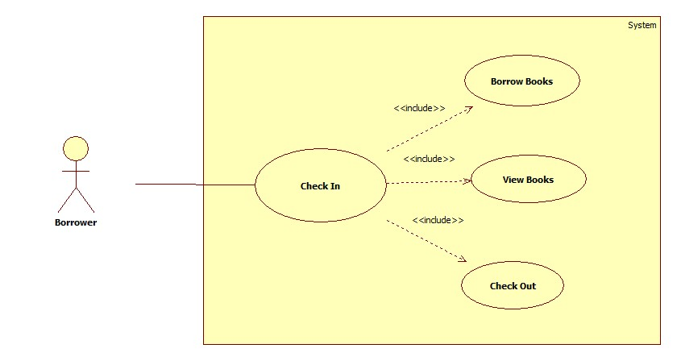

**Figure 2: <Borrower> Check In**

**2.3.1.2.1 <Borrower> Check In**

**Use Case Diagram**

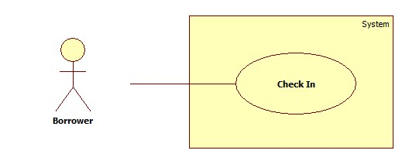

**Figure 2: <Borrower> Check In**

**Use Case Specification**

|  |  |  |  |
| --- | --- | --- | --- |
| **USE CASE – LAR02** | | | |
| **Use Case No.** | LAR02 | **Use Case Version** | 2.0 |
| **Use Case Name** | Borrower Check In | | |
| **Author** | YNX | | |
| **Date** | 24/01/2015 | **Priority** | High |
| **Actor:**  - Borrower  **Summary:**  - This use case allows borrower to check in the system.  **Goal:**  - Borrower login successful.  **Triggers:**  - At the login page, user scan the card with the distance is 3cm.  **Preconditions:**  - User must be borrower.  - Login page is display.  **Post Conditions:**   * Success: Login is successful. * Fail: Login fail and require user scan the card or input PIN again.   **Main Success Scenario:**   |  |  |  | | --- | --- | --- | | Step | Actor Action | System Response | | 1 | Go to Login page | Login page is display | | 2 | Scan the card with distance is 3cm | Authentication page is display | | 3 | User input PIN and click Submit | Display screen of borrower works |   **Alternative Scenario:**  **N/A**  **Exceptions:**   |  |  |  | | --- | --- | --- | | No | Actor Action | System | | 1 |  | Response | |  |  |  | |  |  |  |   **Relationships:** Mối quan hệ với các Use case khác nếu có trong quá trình xử lý, tuy nhiên nó không phải là abstract usecase  **Business Rules:** | | | |

**2.3.1.2.2 <Borrower> Borrow Books**

**Use Case Diagram**

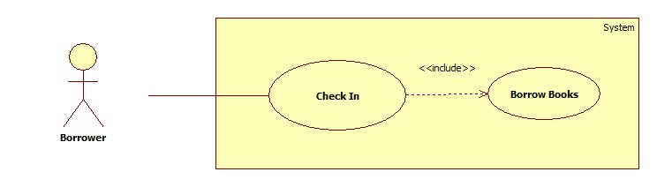

**Figure 2: <Borrower> Borrow Books**

**Use Case Specification**

|  |  |  |  |
| --- | --- | --- | --- |
| **USE CASE – LAR03** | | | |
| **Use Case No.** | LAR03 | **Use Case Version** | 2.0 |
| **Use Case Name** | Borrow Books | | |
| **Author** | YNX | | |
| **Date** | 24/01/2015 | **Priority** | Normal |
| **Actor:**  - Borrower  **Summary:**  - This use case allows borrower to borrow books.  **Goal:**  - Borrower borrow books successful.  **Triggers:**  - At the screen of Borrower works, user click “Borrow Book” button.  **Preconditions:**  - User must be login to system with role Borrower.  - Screen of Borrower works is displayed.  - User chooses Borrow Book function.  **Post Conditions:**   * Success: Information of Borrowed books will be updated to database and the screen will show message “Book has been borrowed successful”. * Fail: Borrowed books won’t be changed and the screen will show message “Borrow book failed. Please try again”.   **Main Success Scenario:**   |  |  |  | | --- | --- | --- | | Step | Actor Action | System Response | | 1 | Go to screen of Borrower works | Display screen of Borrower works | | 2 | Click “Borrow Book” | Information will be updated to database and the screen show message “Book has been borrowed successful” |   **Alternative Scenario:**  **N/A**  **Exceptions:**   |  |  |  | | --- | --- | --- | | No | Actor Action | System | | 1 |  | Response | |  |  |  | |  |  |  |   **Relationships:** Mối quan hệ với các Use case khác nếu có trong quá trình xử lý, tuy nhiên nó không phải là abstract usecase  **Business Rules:** | | | |

**2.3.1.2.3 <** **Borrower > View Books**

**Use Case Diagram**

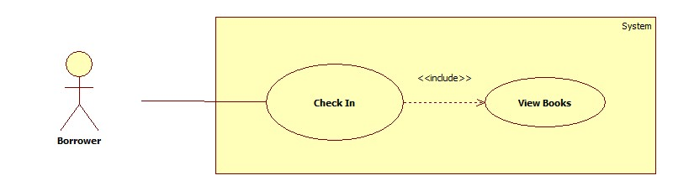

**Figure 2: < Borrower > View Books**

**Use Case Specification**

|  |  |  |  |
| --- | --- | --- | --- |
| **USE CASE – LAR04** | | | |
| **Use Case No.** | LAR04 | **Use Case Version** | 2.0 |
| **Use Case Name** | View Books | | |
| **Author** | YNX | | |
| **Date** | 24/01/2015 | **Priority** | Normal |
| **Actor:**  - Borrower  **Summary:**  - This use case allows Borrower to view books.  **Goal:**  - User can view number of books user has borrowed.  **Triggers:**  - At the screen of Borrower works, user click “View Book” button.  **Preconditions:**  - User must be login to system with role Borrower.  - User chooses View Book function.  - List books are displayed.  **Post Conditions:**   * Success: List books will be displayed. * Fail: List books can not display and the screen will show error message “View books fail. Please try again”.   **Main Success Scenario:**   |  |  |  | | --- | --- | --- | | Step | Actor Action | System Response | | 1 | Go to screen of Borrower works | Display screen of Borrower works | | 2 | Click “View Book” | Show list Books |   **Alternative Scenario:**  **N/A**  **Exceptions:**   |  |  |  | | --- | --- | --- | | No | Actor Action | System | | 1 |  | Response | |  |  |  | |  |  |  |   **Relationships:** Mối quan hệ với các Use case khác nếu có trong quá trình xử lý, tuy nhiên nó không phải là abstract usecase  **Business Rules:** | | | |

**2.3.1.2.4 <** **Borrower > Check Out**

**Use Case Diagram**

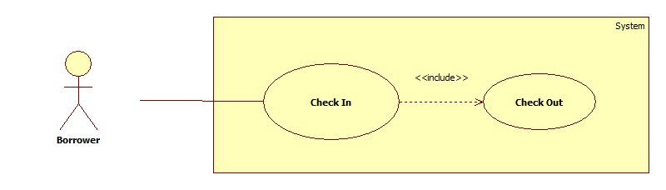

**Figure 2: < Borrower > Check Out**

**Use Case Specification**

|  |  |  |  |
| --- | --- | --- | --- |
| **USE CASE – LAR04** | | | |
| **Use Case No.** | LAR04 | **Use Case Version** | 2.0 |
| **Use Case Name** | Check Out | | |
| **Author** | YNX | | |
| **Date** | 24/01/2015 | **Priority** | Normal |
| **Actor:**  - Borrower  **Summary:**  - This use case allows Borrower to check out.  **Goal:**  - Borrower log out sucessful.  **Triggers:**  - At the screen of Borrower works, user click “Log out” button.  **Preconditions:**  - User must be login to system with role Borrower.  - User chooses Log out function.  **Post Conditions:**   * Success: Log out is successful. * Fail: Logout fail and require user try again.   **Main Success Scenario:**   |  |  |  | | --- | --- | --- | | Step | Actor Action | System Response | | 1 | Go to screen of Borrower works | Display screen of Borrower works | | 2 | Click “Log Out” | Show message |   **Alternative Scenario:**  **N/A**  **Exceptions:**   |  |  |  | | --- | --- | --- | | No | Actor Action | System | | 1 |  | Response | |  |  |  | |  |  |  |   **Relationships:** Mối quan hệ với các Use case khác nếu có trong quá trình xử lý, tuy nhiên nó không phải là abstract usecase  **Business Rules:** | | | |